

Secure System Guidelines
2025
Draft 5.0

Contents
1. Scope 3
2. Definitions 4
3. Guidelines for System Frequency 7
3.1. Operational Application of Frequency Operating Standards 7
3.2. Maximum credible contingency limits (MCCL) 12
3.3. Inertia – Frequency Control Ancillary Service (I-FCAS) 13
3.4. Contingency – Frequency Control Ancillary Service (C-FCAS) 15
3.5. Regulating – Frequency Control Ancillary Service (R-FCAS) 19
4. Guidelines for System Adequacy 21
4.1. Reliability Criteria 21
4.2. Base Capacity 23
4.3. Adequate Energy 24
4.4. Standby Reserve 25
4.5. System Stability 27
5. Guidelines for System Voltage 28
5.1. Voltage Levels 28
5.2. Reactive Power Reserves 29
6. Guidelines for Power System Operations 30
6.1. System Restart and Station Black 30
6.2. Special Protection Schemes 31
6.3. Transmission Capacity 34
6.4. Outage Planning 35
6.5. Fault Level 36
6.6. Protection Integrity 37
7. Registration Thresholds 38
8. Related Records 39
9. Document History 40

Scope
Note:
Updated to reflect that the System Control Technical Code gives rise to the Secure System Guidelines.

The System Control Technical Code prescribes the issuing of Secure System Guidelines by the Power System Controller. Should any conflict arise between this document and the System Control Technical Code, the System Control Technical Code shall prevail.
The Secure System Guidelines sets out the principles determining:
- whether adequate energy and capacity reserves are being maintained on a power system;
- whether adequate reactive power reserves are being maintained on a power system;
- whether satisfactory voltage levels and frequency levels are being maintained on the high voltage networks;
- the capacity of on-line generating units and transmission facilities required by a power system in order that it will withstand unexpected disconnection of load taking System Participants; and
- whether a power system is stable.
For further clarification, understanding or resolution of issues relating to this document, please refer all matters to the Power System Controller.
Where commercial-in-confidence information is necessary to ensure the Secure System Guidelines are sufficiently clear or practically applicable, the relevant information will be specified in confidential Participant-specific documents that are attached separately.

Definitions
Note:
This has been updated and is now linked to the NTC and SCTC definitions where appropriate. Additionally, it has been made clear that the SCTC takes precedence where there is a conflict.
Minor formatting changes to table headers.

Terms defined in the System Control Technical Code and Network Technical Code have the same meaning in this guideline unless specified in this section. Terms defined in the System Control Technical Code and Network Technical Codes are intended to be identified in these Procedures by italicising them, but failure to italicise a defined term does not affect its meaning. In addition, the words, phrases and abbreviations in the table below have the meanings set out opposite them when used in this guideline. Where a conflict arises in definition or meaning, the System Control Technical Code definition and meaning refers.
TERM | DEFINITION
AGC | Automatic Generator Control
AS | Ancillary Service
BA | Bachelor (Zone Substation)
Base Capacity | As defined in Section 4.2 (Determining Base Capacity)
CI | Channel Island (Zone Substation)
CIPS | Channel Island Power Station
Contingency Frequency Control Ancillary Service (C-FCAS) | Services to correct the generation / demand balance following a major contingency event such as the loss of a generation unit, major industrial load, or a large transmission element, as further described in Section 3.4 (Contingency Frequency Control Ancillary Service (C-FCAS))
Contingency Raise or Lower,  Contingency Reserve | As defined in Section 3.4
Credible Contingency Event | As defined in the SCTC
DKTL | Darwin – Katherine Transmission Line
Embedded Generator | As defined in the SCTC
Frequency Control Ancillary Service | The suite of services used by the Power System Controller to maintain the frequency on the electrical system, at any point in time, close to fifty cycles per second as required by the NT frequency standards, as further described in Section 3.1 (Operational Application of Frequency Operating Standards)
Gould AR PLC | A programmable logic circuit installed at MT, PK and KA for the DKTS signalling Scheme
HRSG | Heat Recovery Steam Generator
HV | High Voltage
Inertia Frequency Control Ancillary Service (I-FCAS) | Services that contribute to the capability of the power system to resist changes in frequency by means of an inertial response from a generating unit, network element or other equipment that is electro-magnetically coupled with the power system and synchronised to the frequency of the power system, as further described in Section 3.3 (I-FCAS)
Isochronous (Isoch) | Governor in speed (or Frequency) control mode.
KA | Katherine (Zone Substation)
KPS | Katherine Power Station
kW | Kilo Watt (1,000 W)
Lack of Standby Generation (LOS) | As defined in the SCTC and Section 4.4 (Standby Reserve)
LDC | Line Drop Compensation
LORR | Lack of Reactive Reserve
Material load | Load of a sufficient size such that sudden disconnection may result in a measurable frequency disruption.
MCCL | Maximum Credible Contingency Limits
MT | Manton (Zone Substation)
MW | Mega Watt (1,000 kW)
N Criteria | Equipment operated without redundancy.
N-1 Criteria | Equipment operated with a single level of redundancy.
NTC | Network Technical Code
Network Operator | As defined in the SCTC
OFGS | Over Frequency Generator Shedding
OLTC | On Load Tap Change
PC | Pine Creek 66 kV (Zone Substation)
PCPS | Pine Creek Power Station
PK | Pine Creek 132 kV (Zone Substation)
Power System Controller (PSC) | As defined in the SCTC
Protected Contingency Event | As defined in Section 4.1.2 (Adoption of Reliability Criteria for networks)
PWC | Power and Water Corporation
Reactive Power Reserve | As defined in the SCTC and Section 5.2 (Determining adequate Reactive Power Reserve for the System)
Regulating Frequency Control Ancillary Service (R-FCAS) | Service to correct the generation / demand balance in response to minor deviations in load or generation, as further described in Section 3.5 (Regulating Frequency Control Ancillary Service (R-FCAS))
Regulating Raise or Lower,  Regulating Reserve | As defined in Section 3.5
Rate of Change of Frequency (RoCoF) | As defined in the NTC
SCTC | System Control Technical Code
Shall, will | Mandatory
Should, may | Recommended
Spinning Reserve | As defined in the SCTC and Section 3.4 (Contingency Frequency Control Ancillary Service (C-FCAS))
SSG | Secure System Guidelines
Technical Envelope | The technical envelope means the technical boundary limits of the power system for achieving and maintaining the secure operating state of the power system for a given demand and power system scenario.
UFLS | Under Frequency Load Shedding
WD | Weddell (Zone Substation)
WPS | Weddell Power Station
ZSS | Zone Substation

Guidelines for System Frequency

Operational Application of Frequency Operating Standards
Note:
This section has been revised and replaces the “Determining adequate frequency levels” section. This work is based on the outcomes of a review of the Frequency Operating Standards for the NT Regulated Networks and seeks to make clear the operational application of the frequency standards and ties back to how FCAS is operationally specified to support the frequency management tools NTESMO is developing.
There are three (3) discussion papers (Application of Frequency Operating Standards and Contingency Limits, R-FCAS and C-FCAS discussion papers) that have been prepared to support the changes proposed in this section.

Overview
Frequency Operating Standards are codified within both the Network Technical Code and the System Control Technical Code; these in combination define the limits of frequency operation for both normal and abnormal operating conditions and prescribe the general obligations of the Power System Controller with regards to management of frequency.
This guideline specifies the operational application of the Frequency Operating Standards to support the objectives of the Power System Controller to manage frequency within the regulated power systems. This operational guideline sets out the principles for the maintenance of satisfactory frequency levels and reinforces the approach that is applied with regards to the specification of Frequency Control Ancillary Service (FCAS). FCAS comprises of the combination of Inertia Frequency Control Ancillary Service (I-FCAS), Contingency Frequency Control Ancillary Service (C-FCAS), and Regulating Frequency Control Ancillary Service (R-FCAS).
All FCAS are provided by accredited supply-side resources including generating units, battery storage, and synchronous condensers. FCAS capability provided by System Participants’ facilities is accredited by the Power System Controller. The accredited FCAS capability is subject to periodic amendment through evidence-based post contingency review of facilities’ performance. The Power System Controller retains the obligation to determine and accredit as well as schedule and dispatch facilities to provide FCAS services.

Operational Application of Frequency Operating Standards
The Power System Controller is responsible for the definition of the:
- Three operational timeframes or phases of a frequency event.
- Five operational frequency bands, related back to specific behaviour of the power system.
The three operational timeframes are Containment, Stabilisation, and Recovery and are presented in Figure 1 below.
Figure 1 - Frequency Control and Operational Period Time Domains – Conceptual Illustration
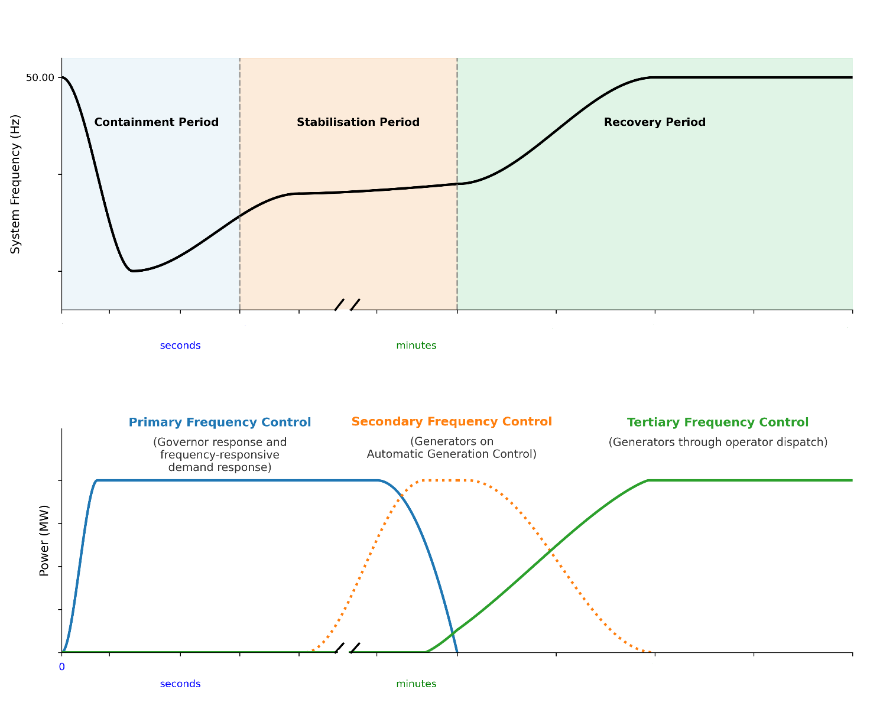
Operationally, the way in which the system transitions between Containment, Stabilisation, and Recovery will vary based on the specific circumstances of each power system disturbance.
- Containment
  - Containment is the time required for automatic actions taken by primary frequency control schemes (e.g. Governor Droop) to arrest and commence the initial recovery of frequency following a power system disturbance.
  - Containment will generally refer to the initial 10 seconds of an event.
- Stabilisation
  - Stabilisation is defined where frequency within the abnormal frequency operating range is stabilised. This generally refers to the phase of an event where secondary frequency controllers (e.g. AGC) are the dominant driver frequency recovery; and the power system has entered a quasi-steady state where frequency has stabilised, but not necessarily returned to the normal frequency operating range.
  - Stabilisation is to be achieved within the first 10 minutes following an event.
- Recovery
  - Recovery is the time where tertiary frequency controls (e.g. Unit Commitment, Unit Dispatch) are the dominant driver of frequency recovery. It is during this phase where frequency is expected to be fully recovered to the nominal operating frequency, and the power system has transitioned back to normal operating conditions.
  - Recovery will typically commence from 10 minutes onwards and is determined by the minimum time taken to manually commit additional generating units into dispatch for each power system.
Each of the five defined frequency ranges relate to a specific method of control and behaviour of the power system. Operationally, the way in which the system transitions between ranges will vary based on the specific circumstances of each power system disturbance. Two of these ranges are specifically defined within the Frequency Standards contained within the Network Technical Code, as noted.
The operational application of frequency bands for each of the regulated power systems is presented in Table 1 and Table 2 below. It is important to note that where “reasonable endeavours” has been identified that it remains within the intent of the Power System Controller to achieve the specified frequency band within the prescribed time to the extent possible without pursuing an inefficient or uneconomic approach. For example, the NTC prescribes a 10-minute maximum stabilisation time (aggregate stabilisation and recovery period) for regulated power systems to assume the normal operating frequency band; however, in the case of the DKPS, for certain power system operating conditions, this will require a substantial additional inefficient commitment of units to achieve the criterion presenting an economically unjustifiable outcome merely to meet a contingency stabilisation period. The Power System Controller will participate in the NT Government’s Electricity Reform Program to seek amendment of the provisions of the NTC in due course to enable a more realistic prescription of the stabilisation time that aggregates the stabilisation and recovery periods. In all circumstances the NTC and the SCTC take precedence over the SSG and the SSG defines operational practices in accordance with the prescribed values represented in the SCTC and NTC.
- Primary Frequency Control Deadband
  - This is the narrow range within which frequency controllers are not required to respond to minor frequency deviations.
  - There is no requirement for any frequency control actions to adjust the system frequency within this band.
- Normal Operating Frequency Band
  - This is a codified frequency band and represents the normal range of frequency operation. This is the frequency range within which the system will operate under normal conditions.
  - Minor correction of frequency toward the nominal frequency is primarily achieved by the active frequency control of the AGC providing frequency regulating services (R-FCAS).
- Normal Operating Frequency Excursion Range
  - Except as a result of a contingency event, this band allows infrequent/momentary excursions outside of the normal operating frequency band.
  - This range allows for flexibility in operation of the power system where there is a momentary non-contingent excursion from the Normal Operating Frequency Band due to the nature of and conditions acting upon the power system during normal operation.
  - This is a regular occurrence in the Northern Territory regulated power systems and is driven by rapidly changing weather conditions across a power system or commitment of generating units that are constrained in their operating envelope.
  - Correction of frequency is expected to be primarily achieved by the active frequency control of the AGC providing frequency regulating services (R-FCAS).
- Credible Contingency Event Frequency Range
  - This represents the frequency operating range for single credible contingency events. Generally, the power system should recover within this band without unduly impacting consumers.
  - The full range of C-FCAS services (primary and secondary frequency control) are utilised within this range to recover the frequency to the normal frequency operating band.
- Abnormal Operating Frequency Band
  - This is a codified frequency band and represents the minimum and maximum limits of operation accepted within the power system. This represents the extremities of frequency operation under non-credible contingency events.
  - Operation within this range is premised upon exhausting the availability of all associated R-FCAS, and C-FCAS services; frequency protection schemes (e.g. UFLS, OFGS) are triggered and activated to arrest frequency deviations and avoid a system restart.
  - Ongoing power system operation within this band is undertaken on a reasonable endeavours approach.

Operational targets for Darwin-Katherine and Alice Springs Power Systems
Table 1 - Darwin-Katherine (Interconnected) and Alice Springs Frequency Bands
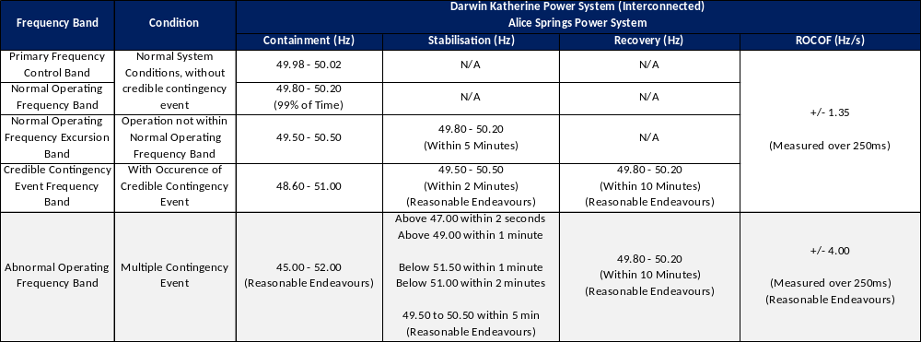

Operational Targets for Darwin-Katherine Islands and Tennant Creek Power Systems
Table 2 - Darwin-Katherine (Islanded) and Tennant Creek Frequency Bands
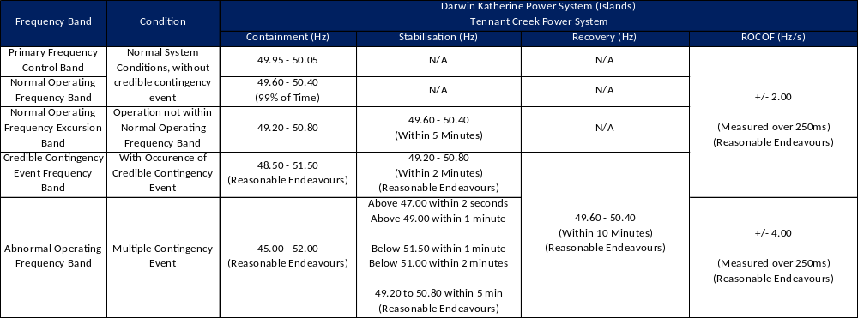

Operational Application of RoCoF Limits
The operational application of the frequency operating standards includes distinctions regarding frequency stability criteria for the allowable RoCoF following credible and non-credible contingency events across the Northern Territory regulated power systems. This operational application seeks to define the appropriate frequency stability limits due to the reduction in system inertia provided by synchronous generators as the generating fleet becomes increasingly dominated by inverter-based renewable generation. The revised application also includes separate RoCoF requirements for islanded systems and Tennant Creek. This is reflective of the different power system operational environment for these regions.
Future revision of the RoCoF limits will be informed by regulatory amendments to frequency operating standards and information regarding withstand capability of the generation fleet as at the time of review. A review of the regional applications of RoCoF will be triggered when there are substantive changes within the respective power system. This would be inclusive of the commissioning and/or decommissioning of assets that provide FCAS or otherwise alter the operational dispatch of FCAS.
The times specified below in the setting of the regional limits are taken as a moving average over the period of frequency change.

Darwin-Katherine and Alice Springs
Credible Contingency Event: +/- 1.35 Hz/s over 250ms
Non-Credible Contingency Event: +/- 4.00 Hz/s over 250ms

Tennant Creek and Islanded Subsystems
Credible Contingency Event: +/- 2.00 Hz/s over 250ms (Reasonable Endeavours)
Non-Credible Contingency Event: +/- 4.00 Hz/s over 250ms (Reasonable Endeavours)

Maximum credible contingency limits (MCCL)
Note:
This is a new section that seeks to clarify the operational and technical envelope to propose an absolute maximum contingency size. Further discussion of contingency definitions and application across the regulated power systems is being developed for a subsequent round of consultation.

Overview
The largest credible contingency that can be withstood within the regulated power systems has been specified to provide clear limits as a basis for FCAS planning and enablement. In contrast, the real-time credible contingency size limit is dynamic and varies throughout the dispatch horizon. It is dependent upon several variables, including the power system configuration, operational demand and dispatch, and the availability and capacity of online FCAS. The real-time credible contingency size limit is less than or equal to the MCCL.
The credible contingency limit applies to any part of the power system which is considered to be a single credible contingency, inclusive of generation, load, and network elements.
Review and update of the maximum contingency size would be based on the evolution of the power system accompanied by modelling of proposed changes.

Regional Application

Darwin - Katherine Power System
The maximum credible contingency limit for the Darwin – Katherine Power System is specified to be 60 MW.
This limit is primarily driven by the need to have a maximum expected size of plant that will be connected to the Darwin – Katherine Power System. As the DKPS changes so too will the contingency size limits change to meet the requirements of the system.

Alice Springs Power System
The credible contingency limit for the Alice Springs Power System is specified to be 10 MW.
This limit is primarily driven by the constrained operation of the largest installed generation units at Owen Springs Power Station.

Tennant Creek Power System
The credible contingency limit for the Tennant Creek Power System is specified to be 2 MW.
This limit is primarily driven by the availability and capability of FCAS within the Tennant Creek Power System.

Inertia – Frequency Control Ancillary Service (I-FCAS)
Note:
This section has been modified to align with the updated sections 3.1 and 3.2 of the SSG.
This limits the scope of this section to dealing with Inertia. Additionally, with the definition of maximum contingency size and ROCOF, there is now a clear means to determine minimum inertia.
References to material load have been reconciled to the registration section.

Overview
Inertia Frequency Control Ancillary Service (I-FCAS) is a subset of FCAS.
The amount of inertia online and size of the contingency event determines the rate at which frequency changes immediately following a sudden imbalance between the supply (generation) and demand (load) arising from:
- An unexpected disconnection of generating units;
- An unexpected disconnection of transmission equipment; or
- Sudden loss of load or fault on the system.
The lower the volume of inertia online, the greater the rate of frequency change immediately following such an event. Post-Contingent Inertia is defined as the sum of all sources of inertia dispatched online, less the inertia associated with the largest credible or protected contingency event. In general, the power system is operated such that sufficient post contingent inertia is available to contain initial RoCoF that:
- Protection schemes (e.g. UFLS, OFGS) operate in an orderly and predictable manner; and
- RoCoF remains within the advised withstand capabilities of assets connected to the power system.
To ensure post contingent management of frequency stability within the power system for protected and credible contingency events, the Power System Controller will take actions as deemed suitable to commit additional inertia online or reduce the contingency size.

Principles of I-FCAS
To achieve the operational application described above, it stands that the power system must be operated with reference to a minimum volume of inertia online. With respect to the guidance provided with regards to the Operational Application of Frequency Operating Standards and by Defining Maximum Contingency Size Limits, the Power System Controller will provide guidance on the minimum inertia levels required for credible and protected contingency events.
In the assessment of the contribution of inertia from participant facilities, it is an important distinction that Synchronous and Non-Synchronous (Emulated, Synthetic) inertia have different operational characteristics. Non-Synchronous inertia will be assessed with regards to additional criteria including:
- Measurement Time;
- Signalling Time;
- Activation Time; and
- Ramping Time.
Based on the assessment of non-synchronous inertia sources, there may be alterations to the combined accreditation of I-FCAS and C-FCAS for participant facilities as deemed appropriate by the Power System Controller.

Regional application
The minimum pre contingent inertia values in the tables below represent the minimum system inertia required to remain secure for a contingency size equal to the contingency limit. In actual operational practice, contingency sizes may be lower than the contingency limit and therefore the minimum pre contingent inertia values will also be commensurately lower.

Darwin – Katherine Power System
CONTINGENCY TYPE | ROCOF LIMIT | CONTINGENCY LIMIT | MINIMUM PRE-CONTINGENT INERTIA
Credible | 1.35 Hz/s over 250 ms | 60 MW | 1150 MWs
Protected/Non-Credible | 4.00 Hz/s over 250 ms | 60 MW | 375 MWs
Implementation Date: Aligned with final implementation of C-FCAS.

Alice Springs Power System
CONTINGENCY TYPE | ROCOF LIMIT | CONTINGENCY LIMIT | MINIMUM PRE-CONTINGENT INERTIA
Credible | 1.35 Hz/s over 250 ms | 10 MW | 185 MWs
Protected/Non-Credible | 4.00 Hz/s over 250 ms | 10 MW | 63 MWs
Implementation Date: Aligned with final implementation of C-FCAS into Alice Springs.

Tennant Creek Power System
CONTINGENCY TYPE | ROCOF LIMIT | CONTINGENCY LIMIT | MINIMUM PRE-CONTINGENT INERTIA
Credible | 2.00 Hz/s over 250 ms | 2 MW | 25 MWs
Protected/Non-Credible | 4.00 Hz/s over 250 ms | 2 MW | 13 MWs
Implementation Date: Aligned with final implementation of C-FCAS into Tennant Creek.

Contingency – Frequency Control Ancillary Service (C-FCAS)
Note:
This section has been significantly altered based on FCAS discussion papers and incorporates the System Frequency Response (SFR) methodology.

Overview
Contingency Frequency Control Ancillary Service (C-FCAS) is a subset of FCAS. C-FCAS and Contingency Reserve are used interchangeably in this context.

Implementation plan
C-FCAS will undergo staged implementation across the three regulated power systems. Darwin-Katherine power system will be the first regulated power system to be transitioned to C-FCAS. The remaining power systems will be implemented at a future date, and they will continue to operate under the legacy Spinning Reserve requirements until further notice.
The algorithms and methodologies used in the accreditation of C-FCAS provision, and the determination for the systems C-FCAS requirement will be implemented in a consistent manner across all regulated power systems. However, prior to final implementation, specific regional requirements of the C-FCAS application will be established with affected system participants.
When all systems are in place to implement the application of C-FCAS requirements within a regulated power system, the Power System Controller will provide all system participants with formal advice of a changeover and update of the Secure System Guidelines. The updated in the Secure System Guidelines will be published a minimum of two weeks in advance of changeover. From the changeover date the affected regulated system will operate with C-FCAS requirements in place of Spinning Reserve requirements.

Principles of C-FCAS
C-FCAS provides a means for the power system to respond to disruption resulting from an unexpected disconnection of generating units, transmission network or sudden loss of load. The C-FCAS requirements application is designed to work in conjunction with any frequency protection scheme (UFLS/OFGS) in place at the time in determining the power system requirements.
The general principles of C-FCAS determination are as follows:
- Dispatch sufficient contingency raise to prevent an UFLS for the loss of any single generating unit (allow for impact of combined cycle units); and return the frequency to a stable level; and maintain until other generating units can be dispatched to return the system to normal operating conditions.
- Dispatch sufficient contingency lower to prevent an over frequency generator trip (full speed no load) for the loss of any load; and return the frequency to a stable level; and maintain until the dispatch can be changed to return the system to normal operating conditions.
The Power System Controller may vary the minimum amount of C-FCAS required to accommodate anticipated variation to credible contingency event size affecting the power system or sub-system at any time. This may include specific generating unit, island, or regional requirements.

C-FCAS methodologies

Determination of the system requirement
The Power System Controller uses a system frequency response (SFR) model to determine the C-FCAS requirements for the system. This model is a simplified representation of the aggregate behaviour of the system frequency in response to active power disturbances. This simplified model includes parameters for:
- Generating Unit changes with respect to frequency changes, including:
  - Inertia
  - Governor action
- Load Damping, also called Load Relief
- Load Inertia
The SFR model has been developed based on the application of the power swing equations, and treating the system with reference to a single frequency:
$$\frac{ d∆f }{dt}=\frac{f_{n}}{2{KE}_{sys}}(P_{m}-P_{e})=\frac{f_{n}}{2{KE}_{sys}}∆P$$
where $∆f$ is the change in frequency (Hz), $∆P$ is the change in active power (MW), ${KE}_{sys}$ is the system inertia (MW.s) and $f_{n}$ is the nominal frequency. Load damping effects are then included with the following modification:
$$\frac{ d∆f }{dt}=\frac{f_{n}}{2{KE}_{sys}}(∆P-DP_{load}∆f)$$
where $D$ is the load damping / relief factor (% MW/Hz) and $P_{load}$ is the pre-disturbance system load (MW). The generic model structure that has been adopted for operational use is shown below in Figure 2.
The differential equations at the core of the SFR model are solved using standard numerical integration techniques to yield a time-domain system frequency trajectory after a contingency. When developing the SFR model, the Power System Controller has made the following assumptions:
- The model ignores network topology and is represented as a single node.
- A single frequency is representative of the system.
- Voltage is well regulated within the system.
- Simplified models are suited for shorter modelling times used.
The SFR model is continually reviewed against actual system events to ensure that tuning of specific parameters maintains an adequate representation of the power system. Operationally this model has been embedded within the Energy Management System used by the Power System Controller to allow real time assessment for C-FCAS requirements.

Figure 2 - SFR Model Structure
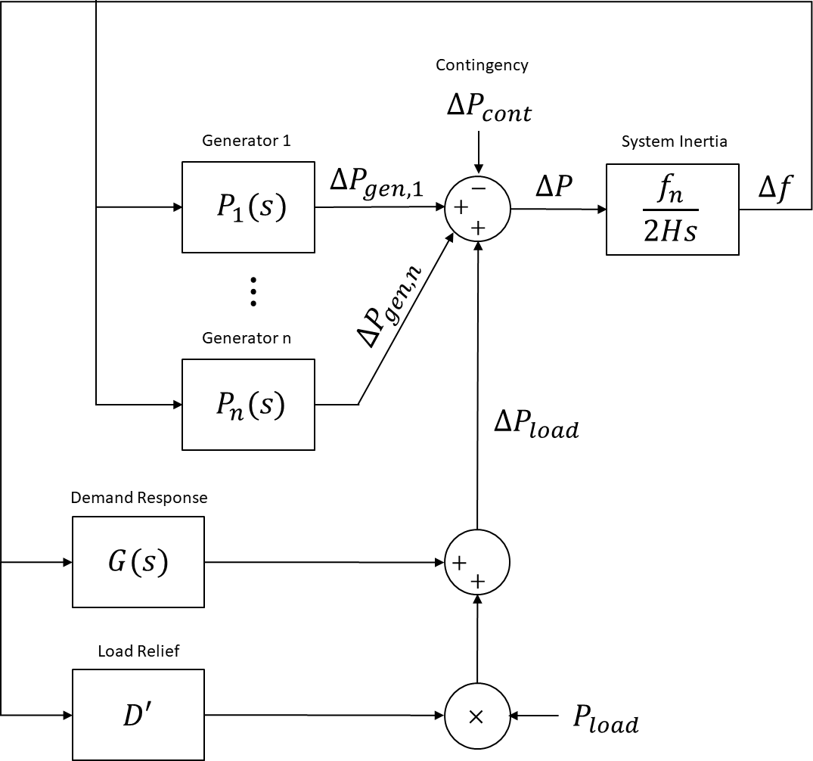

Accreditation of Assets C-FCAS Provision
The Power System Controller will utilise a combined modelling and actual performance review for the accreditation of a system participant’s facility C-FCAS provision. This will be initially conducted by applying a simplified governor model being utilised within a specifically developed script to apply the SFR model process.
An example of the simplified governor model is shown below, steam turbines will have an additional lag block to represent the characteristics of the steam source.
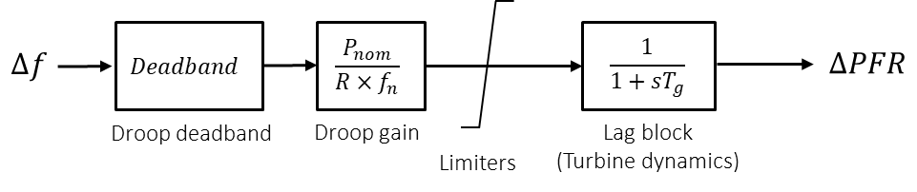
A frequency signal that ramps from 50 Hz out to a 1.5 Hz deviation, and then held at that level, will be used in the assessment of the primary frequency response of participant facility being accredited. This is repeated for a number of initial operating conditions to develop trapezia used in operational calculations.
Once modelling parameters have been determined, a tuning exercise is performed utilising data gathered from actual system events. This will fine tune the values applied to the trapezia used to calculate and accredit the provision of participant’s facility C-FCAS.

Spinning Reserve
Spinning Reserve provides a means for the Power System to ensure that the power system can respond to some disruption resulting from an unexpected disconnection of generating units or transmission network.
At a generating unit level, spinning reserve is calculated as the difference between the current load and base capacity of the generating unit. The Power System Controller will assess non-generator sources of spinning reserve and accredit, to the extent appropriate, in accordance with the principles outlined in this guideline.
At a power system level, spinning reserve is the sum of all individual generating unit spinning reserves. Spinning Reserve must be dispatched across two or more generating units and a minimum amount of spinning reserve must be maintained at all times.
The Power System Controller may vary the minimum spinning reserve available and direct the allocation of generating unit spinning reserve, in anticipation of variation of the credible contingency size of the power system or sub-network at the time.

Regional Application

Darwin – Katherine Power System
Minimum Spinning Reserve: Operationally specified within the Long-term Risk Notice for DKPS.
Changeover to C-FCAS: A staged implementation will commence in September 2025 and participants will be advised one (1) month prior to full implementation.

Alice Springs Power System
Minimum Spinning Reserve: Operationally specified within the Long-term Risk Notice for Alice Springs.
Changeover to C-FCAS: Participants will be advised one (1) month prior to full implementation.

Tennant Creek Power System
Minimum Spinning Reserve: 0.80 MW of Spinning Reserve at all times.
Changeover to C-FCAS: Participants will be advised one (1) month prior to full implementation.

Regulating – Frequency Control Ancillary Service (R-FCAS)
Note:
This section has been significantly altered based on R-FCAS discussion papers, it incorporates the System Frequency Response (SFR) methodology and applies a probabilistic regulating methodology. It also aligns with the changes in section 3. It also aligns with the changes in section 3.
Proposed streamlined table of the outcomes of the R-FCAS work has been included.

Overview
R-FCAS is a subset of FCAS. R-FCAS and Regulating Reserve are used interchangeably in this context.
Regulating Reserve is that capacity of a generating unit or units available to regulate frequency to within the defined normal operating frequency band including any required time error correction. Regulating Reserve is only the amount required to follow load changes and output variation in unregulated generating units (embedded or registered), not the acute loss of load or load restoration following loss of load. Acute loss of load this is accounted for by contingency lower provisions as defined in Section 3.4 (C-FCAS).

R-FCAS Principles
The minimum amount of Regulating Reserve will be a dynamic requirement based as per the following:
$Minimum Regulating Reserve= Greater of\left\{\begin{aligned}Minimum Regional Figure \\ System Load Rate of Change\end{aligned}\right.$$Minimum Regulating Reserve=\operatorname{maximum}{ \left\{\begin{aligned}Minimum Regional Figure \\ System Load Rate of Change\end{aligned}\right.}$
System Load Rate of Change is a dynamic figure determined by the change (or anticipated change) in the summation of all online machine MW output over the region-specific duration. The region-specific duration is defined as twice the average regulating generating unit start time. This allows for a single failure to start a regulating generating unit without breaching the Minimum Regulating Reserve requirement.
System Load Rate of Change accounts for readily predictable load changes, such as forecast weather changes that may affect load. Where this is not practical, the Power System Controller will determine an appropriate course of action.
The Power System Controller will schedule and dispatch the regulating generating units which regulate frequency and determine the control mode for all regulating generating units. Regulating Reserve will be altered as required under planned/forced outages (e.g. Islanding) on a case-by-case basis.
The Power System Controller will ensure regulating reserves are such that typical load changes and output variation in unregulated generation (embedded or registered) do not result in frequency deviations outside the normal operating frequency band.

R-FCAS Methodology
The R-FCAS methodology only applies to the Darwin-Katherine Power System and upon further review may be extended to cover the Alice Springs and Tennant Creek power systems.
The System Load Rate of Change is calculated separately for different periods classified as:
- each season, being dry and wet seasons;
- different days, being weekdays and weekends; and
- times of day (referred to as time periods).
System Load Rates of Change will be specified for seasons, day type, and time periods to the extent necessary to ensure sufficient regulating reserves are maintained.
The System Load Rate of Change is determined separately for the upward (raise) and downward (lower) directions, informing regulating raise and regulating lower requirements. These values are derived from a probabilistic assessment of at least 12 months of historical demand data at a 5-minute resolution.

Regional Application

Darwin - Katherine Power System
Minimum Regional Figure of 5 MW.
System Load Rate of Change as determined by the R-FCAS methodology:
TIME PERIOD | TIME | RAISE (DRY) | RAISE (WET) | LOWER (DRY) | LOWER (WET)
Weekday early morning | 5am – 7:30am | 18 MW |  | 3 MW
Weekday late morning | 7:30am – 11am | 6 MW | 11 MW | 13 MW
Weekend morning | 5am – 11am | 6 MW | 10 MW | 8 MW | 11 MW
Afternoon | 11am – 6pm | 16 MW | 20 MW | 8 MW | 13 MW
Overnight | 6pm – 5am | 5 MW |  | 12 MW
The values represented in this table may change in accordance with the evolving dynamic operating circumstances in the DKPS to which NTESMO is expected to respond by applying the System Load Rate of Change. The values are for indicative guidance purposes and do not to bind NTESMO where operating circumstances warrant the application of a different System Load Rate of Change. The same conceptual requirement for operating flexibility applies to the Tennant Creek and Alice Springs Power Systems.

Tennant Creek Power System
Minimum Regional Figure of 0.5 MW.
System Load Rate of Change defined as change in system load over 10 minutes.

Alice Springs Power System
Minimum Regional Figure of 2 MW.
System Load Rate of Change defined as change in system load over 10 minutes.

Guidelines for System Adequacy
Note:
From this point onwards, the changes are:
- Formatting
- Sectionalisation/Grouping
- Minor edits regarding SCTC/NTC references
- Updating references to most recent and up-to-date versions

Reliability Criteria

Overview
The Power System Controller adopts the following reliability criterion for network primary plant. Such criterion will be employed for maintenance planning and coordination:
Equipment that cannot be operated to ‘N-1 Criteria’ due to means of connection, are operated to ‘N Criteria’. E.g. distribution feeders.
Equipment that could be operated according to N-1 Criteria is classified into 3 groups:
- Non-Credible (Operated to ‘N Criteria’)
- Protected (Operated to prevent system black)
- Credible (Operated to ‘N-1 Criteria’)
Under normal conditions the following are deemed to be non-credible contingencies:
- Bus faults
- Three phase faults
Under normal conditions, the following contingencies are classified as protected:
- Loss of the 132 kV Transmission line south of Channel Island – Only to the extent that the southern region may go black, impact to the remainder of the Darwin-Katherine System is managed as a credible contingency and should not result in UFLS.
- 132 kV Channel Island Nodes are operated as protected events. Outage planning and dispatch is managed to prevent System Black, however UFLS may occur.
- Loss of multiple transmission lines due to shared towers.
Fuel Supply contingencies are handled under Section 9 (Determining adequate energy for the System). The remainder of contingency events are considered credible.
Under planned or forced outage contingencies, the Power System Controller may reclassify contingencies.

Protected events and credible contingencies
The Power System is operated under the principle that credible contingencies wherever possible shall not result in involuntary load shedding. There are exceptions for planned outages where risk of involuntary load shedding is unavoidable, however in these cases risk analysis and mitigation is undertaken. This requires system constraints in place and scheduling of planned generation and network outages to ensure reliability criteria are at acceptable levels.
There are single contingency events that are plausible to occur, however the impact of enforcing constraints to prevent involuntary load shedding for these contingencies is impractical to apply on a permanent basis. These contingency events are classified as protected events such that constraints and scheduling of planned generation and network outages will only be enforced to ensure Power System Security is maintained to the extent required to avoid System Black. These events may be reclassified as credible if the Power System Controller deems necessary due to an identified increase in risk.
For the contingency of a radial line, the resultant impact to the wider system is considered and treated as credible (constraints are enforced to prevent UFLS/OFGS). The local impact (Loads/generation) on the radial is managed under ‘N criteria’ for reliability, unless determined otherwise by the Power System Controller.

Base Capacity

Overview
Base Capacity is defined as the maximum sustainable output in a generation unit under the worst seasonal ambient conditions. Base capacity of generating units shall not take into account use of facilities that might provide short term (defined as 4 hours or less) capacity gains.
For a generating unit with a staged output capability (such as water injection) the unit will have a variable base capacity. This base capacity of such unit will consider the availability of the staged output, whether it is currently online and the intended utilisation of this capacity. I.e. if a staged output is available but offline, it may count towards planning criteria for maintenance outages, but not to spinning reserve/C-FCAS.
Base Capacity will be according to advice from the System Participant to the Power System Controller. System Participants shall provide the Power System Controller with advice of any variation to the Base Capacity of a unit promptly in writing. The Power System Controller is responsible for accrediting these Base Capacities provided by the System Participants and may amend the figure as required.
The Power System Controller will take a conservative approach in accrediting Base Capacity of a generating unit. An untested increase in Base Capacity may be accredited at a lower value than the Participants’ advice until there is an appropriate opportunity to test under the worst expected seasonal ambient conditions.
The Power System Controller is cognisant of the business requirements involved with tests and will endeavour to undertake these tests where they minimise impact to System Participants (e.g. following a machine start where there is a surplus of Spinning Reserve/C-FCAS).

Regional Application
Refer to Section 8 (Related Records).

Adequate Energy

Overview
Energy supply adequacy is generally measured by the quantity and quality of fuel available for use at each power station.
An Alert level is defined as a case where available fuel supply falls below that quantity or quality required for operation at forecast load levels for the next 8 hours.
Due to the complexity of arrangements required to deal with shortfalls in fuel supply, or departures from quality standards, it is necessary that there be a Preliminary Alert level where any contingency in the delivery and or storage systems for fuel supply has the potential to result in an Alert level being reached in the next 18 hours.
Generators shall immediately notify the Power System Controller when a Preliminary Alert or Alert level is reached.
Where more than one fuel source and/or fuel type is available each source/type should be monitored and subject to the Alert level process.
When the Power System Controller has been notified of a fuel adequacy alert the Power System Controller may then deem that the partial or complete loss of the generating system is a credible contingency. The Power System Controller will communicate with affected participants and may take measures to mitigate this risk; these measures may include making directions as provided for by the SCTC.

Standby Reserve

Overview
The Power System Controller will determine the required generation capacity of a power system according to the summation of:
- the actual or forecasted load of the power system,
- the required spinning reserve or C-FCAS raise of the power system, and
- the capacity at risk from a credible or protected contingency event.
The Power System Controller will declare a Lack of Standby Generation (LOS) condition when the available generation plant capacity is below the calculated required generation capacity. LOS Conditions will be classified according to the considered actual or expected severity of generation shortfall.
Breach of the technical envelope as indicated in the LOS conditions below, would include insufficient post contingent inertia to meet the requirements set out in Section 3.3 (Inertia – Frequency Control Ancillary Service (I-FCAS)). The Power System Controller will assess LOS levels with regards to inertia in addition to generation base capacity as outlined above (when the Inertia Frequency Control Ancillary Service is implemented on a regional basis).

LOS1 Condition
LOS1 is declared when the occurrence of a protected contingency event involving the loss of the largest available generation node in the power system will result in the power system operating outside the technical envelope.

LOS2 Condition
LOS2 is declared when the occurrence of a single credible contingency event involving the loss of the largest generation unit available in the power system, will result in the power system operating outside the technical envelope.
In determining the largest available generation unit, the effective load of an online combined cycle unit is deemed to be the load of the open cycle unit plus the inferred load derived from its associated HRSG.

LOS3 Condition
LOS3 is declared when the power system is operating outside of the technical envelope, the minimum spinning reserve or C-FCAS raise has been breached and/or the Power System Controller is implementing measures to maintain system security.

LOS Margins
LOS Margins set the boundaries for determining and declaring when the power system is in any of the three LOS Conditions. The following figure provides the formulae the Power System Controller will utilise to calculate the three LOS margins, and illustrates the application of the LOS Margins to determine LOS Conditions.

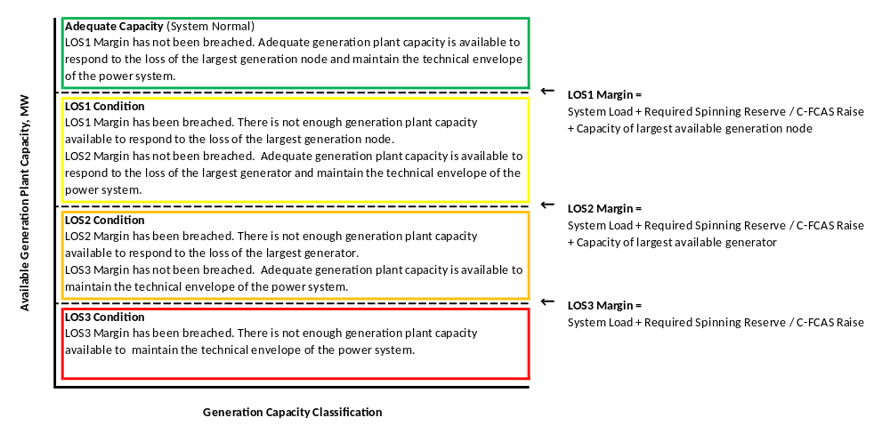

System Stability

Overview
Any equipment identified as causing Voltage instability or Frequency instability event may be disconnected as directed by the Power System Controller or directed to undertake rectification actions to ensure such an event is not caused in future.

Definition
The AEMO Power System Stability Guidelines definitions of stability as quoted below are used by the Power System Controller to assess system stability.
AEMO POWER SYSTEM STABILITY GUIDELINES V1.0 Stability Definitions
1.4 Voltage stability
Voltage stability is the ability of the power system to maintain or recover voltage magnitudes to acceptable levels following a contingency event.
Instability would result in voltage magnitudes in part of the power system exhibiting an uncontrolled sustained increase or decrease over time (a “run-away” condition) or sustained or undamped oscillatory behaviour. Voltage instability can occur rapidly (over seconds) or slowly (over minutes).

1.5 Frequency stability
Frequency stability is the ability of a power system to maintain acceptable frequency following a contingency event. Typically, that contingency event causes an unbalance between generation and load in the power system. It depends on the ability of the power system to maintain or restore equilibrium between generation and load and recover the power system frequency to acceptable levels.
Instability results in an uncontrolled sustained increase or decrease over time (a “run-away” condition) or sustained undamped oscillatory behaviour.

Determination
Refer to Section 3.1 (Operational Application of Frequency Operating Standards) of this guideline for frequency ranges.

Guidelines for System Voltage

Voltage Levels

Overview
System Voltage is a distributed, locationally specific phenomenon, and its limits are defined in various Acts, Regulations, Codes and Standards.
The Network Technical Code requires that all plant be designed to operate with minimum and maximum steady state voltages to 90% and 110% of nominal design voltage respectively, unless specifically designed and approved. Generally, contestable customers are expected to design their plant to accept voltage levels of +/- 5% of nominal voltage.
The Network Technical Code also defines:
- Maximum voltage perturbation for a routine switching step (excluding de-energising) +/- 3.7% nominal voltage before reactive control responses and
- Maximum voltage perturbation for an infrequent switching step (excluding de-energising) +/- 6% nominal voltage before reactive control responses.
System Voltage Reduction is a credible means of reducing load under emergency conditions, but has the impact that customers at feeder extremities may suffer voltages outside of nominal range. Only the Power System Controller approves Voltage Reduction strategies.

Regional Application
Normal voltage control limits for all regulated voltage nodes regulated by OLTC transformers shall be +/-1.5% of a specifically defined nodal voltage value.
LDC (Line Drop Compensation) usually provides benefits for very long feeders with relatively large loads at the ends of the feeders. Typically, fixed value (no LDC) regulated voltage set-points are set slightly higher than nominal to allow for voltage drop at the ends of the feeders. The latter type is in most common use in PWC.
Control balance points are as follows:
NOMINAL VOLTAGE | TYPICAL VOLTAGE SETPOINT | TOLERANCE
132 kV | Not controlled by OLTC | +/- 10% nominal
66 kV | 67.6 kV | +/- 10% nominal
22 kV | 22.5 kV | +/-5% nominal
11 kV | 11.1 kV | +/-5% nominal

Reactive Power Reserves

Overview
There are nominal design voltage levels and tolerances defined within this guideline. The system voltage at each node and, corresponding reactive power requirements, are determined by power system local demand and the reactive impedance of the various sections of the power system.
Measures of adequate reactive power reserve include:
- voltage levels for the System meet Adequacy limits
- there is no ZSS OLTC transformer that has reached maximum or minimum tap and regulated voltage is within normal control deadbands
- voltage collapse situations are not imminent
- no generator is operating close to maximum or minimum excitation level and under automatic control
- Power Factor on ZSS Buses are within normal ranges

Application
Power System Controller will issue advice to all affected system participants when:
Lack of Reactive Reserve 1 (LORR1):
- Any OLTC transformer is operating at Top or Bottom tap and regulated voltage remaining outside normal control deadbands OR,
- any scheduled generation unit is operating within 5% of maximum or minimum excitation level and under automatic control OR,
- 2 scheduled generating units are operating under manual voltage control
Lack of Reactive Reserve 2 (LORR2):
- Any system voltage-controlled node operating outside of statutory voltage limits OR
- any system node operating outside of stable voltage control limits OR
- any generation unit operating at maximum or minimum excitation level and under automatic control OR
- 3 or more scheduled generating units operating under manual voltage control.
Power System Controller may initiate commensurate actions including directions, load shedding, load transfer, or generation plant adjustments at any of these stages.

Regional Application

Darwin - Katherine Power System
In addition to above, LORR1 will also be issued if the sum of in-service reactive power from Capacitor Banks in the system is below the requirements specified in the Long Term Risk Notice.

Alice Springs Power System
No additional requirements.

Tennant Creek Power System
No additional requirements.

Guidelines for Power System Operations

System Restart and Station Black
The System Control Technical Code requires that each generating system capable of Black Start shall submit to the Power System Controller a procedure to start generation plant and prepare to take load when connected to the power system. To maintain the effectiveness of Black Start procedures they must be regularly audited, updated, and resubmitted. The Power System Controller shall from time to time require that Black Start procedures be tested in a manner that will be agreed by the parties.
The SCTC requires that the Power System Controller develop a Black System Restart procedure. The guiding principles of the Black System Restart are:
- Safety of public and personnel.
- Integrity of Power System Plant and Equipment
- Restoration of normal supply whilst maintaining conformance with the provisions of relevant Technical Codes and Secure System Guidelines.
In determining the priority for restoration of normal supply the guiding principles of the System Black Restart are:
- Essential to any System Black Restart is the early identification of the cause of the System Black, in order that any causal condition is avoided in the process of Black System Restart.
- The connection of a generating system that has completed its’ Black Start to an appropriate type of load.
- The interconnection of generating systems and the restarting of generating systems without black start capability.
- The continued connection of load to the power system with priority given to hospitals and facilities necessary to maintain the health and security of the public. Priorities may also be set as part of disaster response processes of Power and Water and/or the NT Government.
Refer to document “Regulated Power System – Black System Procedures” in Section 8 (Related Records), or station specific black start procedures.

Special Protection Schemes
The Power System Controller has oversight of the following control and protection schemes to cater for credible system security contingencies such that supply is maintained or returned to within the technical envelope:

DKTL System Status Signalling Scheme
The Darwin Katherine Transmission Line (DKTL) has connections to generation facilities at Pine Creek Power Station (PCPS) and Katherine Power Station (KPS).
In normal circumstances, if these facilities are on-line, PCPS and/or KPS will be under AGC control and their governors in droop mode.
However, if any of the Lines, Busbars or Transformers become isolated under protection action or deliberate switching it is necessary to have governor and excitation modes switch to Isochronous (Isoch) and voltage control within a matter of seconds in order that frequency and voltage control be maintained. Table 1 shows Scheme responses to potential events:
DKTS ELEMENT ISOLATED | PCPS ON-LINE | PCPS CONTROL MODE | KPS CONTROL MODE (IF ON-LINE)
CI-MT | Y | Isoch/Voltage | No change
CI-MT | N | No Change | Isoch/Voltage
MT-BA-PK | Y | Isoch/Voltage | No change
MT-BA-PK | N | No Change | Isoch/Voltage
PK-KA | Y | No Change | Isoch/Voltage
PK-KA | N | No Change | Isoch/Voltage

Further detail:
Connectivity is based on circuit breaker status, taken from the Gould AR PLC at MT, PK and KA. Circuit breaker status at CI is taken from the 132CI210 Circuit Breaker C60 relay. A circuit breaker isolated for maintenance, and closed as part of the work, will cause a status change. The scheme was designed to deal with faults; if the outage is planned then part of the planning should be to manually select Isoch at the appropriate site for the duration of the work after the initial switching.
Signalling is carried out by microwave communications which are duplicated and pilot wire communications between PK and PC, which are not.
Both PCPS and KPS have separate and independent “Local Isoch” functions whereby circuit elements local to the power stations are monitored and also cause a change to Isoch mode.

Power Station Anti-Islanding Requirements
A generating system that is not capable of maintaining appropriate frequency and voltage limits while not operating in parallel with one or more other generating systems connected to the power system, shall have control/protection systems in place to immediately disconnect from the power system at the relevant connection point, if that parallel connection is interrupted.

Under-Frequency Load Shedding Scheme
Under the terms of the System Control Technical Code a UFLS scheme shall be implemented to ensure that where other provisions of the Secure System Guidelines fail to maintain frequency within the appropriate ranges, circuits/load will be disconnected to the extent, and within the time required, that will return the power system to a satisfactory operating state.
Under normal operating conditions at least 75% of all load in each region is to be selected for UFLS.
Refer to document “Under Frequency Load Shed Schedule” in Section 8 (Related Records).

Over-Frequency Generator Shedding Requirements
Over-Frequency Generator Shedding (OFGS) may be in place where other provisions of the Secure System Guidelines fail to maintain frequency within the appropriate limits appropriate generators will be disconnected to the extent, and within the time required, that will return the Power System to a Satisfactory State.
There are no current or planned OFGS schemes in place as the configuration and operation of the three regulated systems is such that the above requirements are met by generator protection. Within each region the generator over frequency protection settings shall be unique and provided to the Power System Controller. The System Controller may require changes made to over frequency protection settings of any generating unit and the participant will ensure these settings are changed promptly.
Refer to document “Secure System Guidelines Generation Specifics” in Section 8 (Related Records).

Embedded Generation Anti-Islanding Requirements
All embedded generation plant (of any type/technology) that is permanently or occasionally connected in parallel with the Power System, shall have control/protection systems in place to prevent the possibility of exporting power into the Power System, unless that export is:
- in parallel with Power System source(s), and,
- explicitly permitted by a Connection Agreement, and, on each and every occasion of such export, by explicit permission of the Power System Controller.

Embedded Generation Anti-Paralleling Requirements
Where an embedded generation plant has multiple connection points to the power system, control/protection systems shall be in place that prevent a parallel connection between one or more connection points, unless explicitly permitted by a Connection Agreement, and, on each and every occasion of such parallel, by explicit permission from the Power System Controller.

Power System Islanding Requirements
Depending on the topology and configuration of a power system there may exist points at which connections may be opened in order that autonomous generation and load areas are formed, usually consequent to a major system wide disturbance, with the aim being to facilitate preventing a System Black event. While not implemented as of 2025 this is a provision that may in future be implemented if feasible.

Transmission Capacity
The Network Operator is responsible for determining ratings of the transmission assets. The Network Operator shall advise the Power System Controller of these ratings. The Network Operator shall provide ratings for transmission equipment in the manner specified by the Power System Controller:
- A minimum of 2 weeks prior to commissioning of any transmission equipment,
- immediately upon any assessed change to the rating of an asset
- whenever requested by the Power System Controller within an agreed timeframe.
The Power System Controller shall utilise any limit provided by the Network Operator for a given asset as required for normal operation, planned maintenance or otherwise.
The Network Operator shall provide ratings according to the following terms which are used to determine the capacity of transmission assets:
Table 3: Transmission Rating Requirements
TERM | DESCRIPTION
Transformer Rating | The Continuous and Emergency Rating provided by Network Operator (Asset Management) associated with the transformer
Line Rating | The Continuous and Emergency Rating provided by Network Operator (Asset Management) associated with the Transmission Line
Bay Rating | The Continuous and Emergency Rating provided by Power Network associated with the related assets in the bay
Relay Load Limit | The Continuous and Emergency Rating provided by Network Operator (Test and Protection)
Normal Continuous Ratings | Continuous Rating with no time restrictions
Emergency Rating | Emergency Rating with an associated time restriction provided
Short Term Relay Load Limit 1 and 2 | The exceedance of the MVA/Amps Limits provided for the specified time duration will trip the plant
Effective Continuous Rating | The most conservative Continuous Rating between the Transformer Rating, Bay Rating and the Relay Load Limit
If there is a rating or restriction on plant that does not fit in the terminology provided above, the Network Operator remains obligated to advise the Power System Controller.

Regional Application
Refer to Section 8 (Related Records).

Outage Planning
In approving the disconnection of power system elements for scheduled and planned, generation or transmission outages, the Power System Controller will determine the specific requirements necessary to maintain the security and reliability of the power system for the duration of the outage. The requirements to maintain security and reliability will extend to cover the occurrence of credible contingency events that have been identified or reclassified as part of the assessment.

Generation Outage Approval
Planned generation outages, or planned transmission outages which place a constraint on generation, will be assessed based on reliability of the power system under a credible or protected contingency event. The Lack of Standby Generation criteria defined in Section 4.4 (Standby Reserve) will apply. Planned outages which trigger a breach of the LORR1 or LOS2 margin will not be granted approval. Planned outages which trigger a breach of the LOS1 margin will be assessed on a case-by-case basis and may be approved under the majority of circumstances, however a LOS1 condition will be declared.
When generation units are undergoing online testing, the Power System Controller will define the required spinning reserve or FCAS requirements (Contingency and Inertia FCAS may be specified) necessary to facilitate the testing while maintaining power system security and reliability.

Network Outage Approval
At all times, the power system must operate within its defined technical envelope and maintain system reliability. The ratings of power system elements supplied by the System Participant will be utilised to determine the technical envelope of the power system. Planned outages which trigger a breach of the LORR1 margin will not be granted approval.
In circumstances where planned network outages pose heightened risk to system reliability due to extended recall time, the System Controller may require a system participant to submit an appropriate emergency restoration plan. Approval of such planned outages will be conditional on the acceptance of the emergency restoration plan.

Timeframe for Outage Planning
Refer to the System Control Technical Code for specific details associated with Annual Plant Maintenance Forecasts and Application for Plant Outages.
Any application for Plant Outage less than the duration specified in the System Control Technical Code must provide sufficient justification for the lack of notice and requires approval by the Power System Controller.

Fault Level
The Network Operator shall advise the Power System Controller of:
- the fault level rating of all transmission equipment down to feeder circuit breaker equipment at zone substations. This may include the fault level rating of distribution equipment as seen at the zone substation.
- any system configuration that may result in prospective fault levels above fault level rating of transmission, or distribution equipment.
- any system configuration that may result in prospective fault levels below the requirement for protection to operate as designed.
The determination of whether equipment or configuration which may breach fault level requirements shall include (but is not limited to) an assessment of the following:
- Possible configuration of distribution equipment.
- Possible network configurations (including during system restart).
- Possible generation dispatches (including dispatch for minimum/maximum demand or other worst case).
- Any other factor likely to contribute or detract from the fault level rating or minimum required fault level of switchgear.
The Network Operator will work in conjunction with the Power System Controller to develop operational configurations to mitigate risk of prospective fault levels exceeding ratings or below the requirement for protection to operate as designed.
The Network Operator shall assess fault levels for any relevant change to distribution or transmission equipment. This may include (but is not limited to) the following:
- Commissioning of equipment
- De-commissioning of equipment
- Protection setting modification
- Significant change in network or distribution configuration.
Specific limits and requirements for network fault level ratings are outlined in the Network Technical Code.

Protection Integrity
When a planned outage of a protection scheme for a transmission element is requested, the Power System Controller will assess the risk to system security and make a determination on the most appropriate action, be it to leave the transmission element in service for a limited duration, to take the transmission element out of service, and/or to put temporary protection equipment or measures in place.
When a planned outage is scheduled for one of two independent protection schemes on a transmission element, the duration shall be kept to a minimum, and not exceed eight hours, unless the Power System Controller has granted prior approval.
Protection schemes will only be considered independent if appropriate redundancy and separation of equipment exists, each protection system is capable of performing the same fault detection / isolation functionality, and each protection system has the facility to alert the Power System Controller via SCADA in the event of equipment failure. The requirement for separation of protection equipment extends to secondary equipment including, but not limited to, CT and VT secondaries, auxiliary supplies, cabling and wiring, circuit breaker trip coils, and battery and inter-tripping arrangements.
In accordance with the System Control Technical Code, a system participant must advise the Power System Controller immediately whenever the system participant becomes aware that any protection scheme equipment is not operating correctly. The system participant is responsible for ensuring that the Power System Controller is kept informed while any such scheme is promptly and diligently repaired or replaced. The Power System Controller shall make a determination regarding the continued serviceability of affected high voltage equipment, and initiate any additional operational actions to mitigate the perceived risks.

Registration Thresholds
The Power System Controller must be aware of any material step change in load or change in output of embedded generation to ensure supply to all customers is within the technical envelope and appropriate generation dispatched. As such thresholds for registration of generation (embedded or otherwise) and switchable loads are specified by region.
As part of the Network Connection process, a generator or load exceeding the region-specific threshold shall be registered with the Power System Controller prior to connection.
The System Controller may impose various connection requirements for a registered generator or load including, but not limited to:
- High speed data recording
- Remote control capabilities
- Inter-trip or other protection schemes
- Operational communication requirements
- Ramp rates.
These connection requirements will be determined on a case-by-case basis.
The Power System Controller may require a registered generator or load to exercise any of the following actions (the list is not exhaustive) for system security:
- Adjust output/load
- Voltage Control
- Frequency Control
- Disconnect.

Regional Application

Darwin - Katherine Power System
Registration Threshold:
Connection in possible radial islands at Katherine, Pine Creek, Batchelor, or Manton Zone Substations:
200 kW
Connection in possible radial islands at Archer, Humpty Doo, Marrakai, Mary River, Palmerston, Strangways, Weddell or Wishart Zone Substations:
500 kW
Elsewhere within Darwin/Katherine System:
1000 kW

Alice Springs Power System
Registration Threshold: 200 kW

Tennant Creek Power System
Registration Threshold: 30 kW

Related Records
Related records and procedures are to be stored in:
- The System Control Operational Document Facility accessed through the intranet web site for System Control.
- Power and Water’s Records Management System (CM9) in accordance with the Corporate Document and Record Control Procedure.
- Records are to be retrievable through Power and Water’s Record Management System.
Upon request to the Power System Controller a record may be made available in part or full where appropriate.
NO. | DOCUMENT | DATE | LOCATION/HPE NO.
1 | System Control Technical Code | Feb 2024 | Published Online
2 | Network Technical Code and Network Planning Criteria | March 2020 | Published Online
3 | Secure System Guidelines Generation Specifics
4 | Secure System Guidelines Network Specifics
5 | Alice Springs System Security Dispatch Constraints | 05/08/2016 | D2016/316637
6 | Under Frequency Load Shedding Schedule | Feb 2025 | BDOC2015/135
7 | Regulated Power System – Black System Procedures | 01/11/2023 | CONTROL0740
8 | Channel Island Power Station Black Start | 25/09/2024 | TGEN DOC CONTROL0103
9 | Weddell Power Station Black Start | 22/06/2021 | TGEN DOC CONTROL0441
10 | Katherine Power Station Black Start | 02/06/2022 | TGEN DOC CONTROL0440
11 | Ron Goodin Power Station Black Start | 12/08/2021 | TGEN DOC CONTROL0162
12 | Owen Springs Power Station Black Start (MAN Units) | 09/02/2022 | TGEN DOC CONTROL0552
13 | Tennant Creek Power Station Black Start | 22/06/2022 | TGEN DOC CONTROL0282
14 | C-FCAS Methodology – System Requirement
15 | C-FCAS Methodology – Asset Provision
16 | R-FCAS Methodology

Document history
The Secure System Guidelines is reviewed as required following the amendment of technical codes or where there are significant changes within any of the regulated power systems. As a minimum the guideline shall be reviewed every 5 years.
REVISION | DATE | STATUS/CHANGE | UPDATE BY | REMARKS
Version 2.6 | Aug 2008 | Issued | Ken Lewis | Issued
Draft 3 | Dec 2016 | Reviewed for consultation | Power System Controller | Reviewed. Substantive changes throughout. Ready for consultation.
Draft 3.1 | May 2017 | Consultation Preliminary Review changes | Power System Controller | Darwin-Katherine Spinning Reserve and C4/C5 Node contingency Short Term Advices included. Other minor changes.
Draft 3.2 | June 2017 | Consultation Review Changes | Power System Controller | Clarification on Frequency Control Ancillary Service usage/definitions. Alice Springs Short Term Advice included.
Version 4 | July 2017 | Issued as final | Power System Controller | Sections re-ordered. No other change from Draft 3.2
Draft 4.1 | Dec 2018 | Preliminary Consultation Draft | Power System Controller | Draft changes required by introduction of Generation Performance Standards
Version 4.2 | Apr 2020 | Issued as final | Power System Controller | Changes required by introduction of Generation Performance Standards
Draft 5.0 | July 2025 | Preliminary Consultation Draft | Power System Controller | Revised document format to align with SCTC and NTC format  Restructured to align with SCTC prescriptions  Updated application guidelines for frequency management (Section 3)  Updated document template  Minor editing and formatting changes.

a
Contact
NTESMO Power System Controller
Core Operations
market.operator@powerwater.com.au
powerwater.com.au

System Control Technical Code, Version 7.0, February 2024, Section 3.5.1, page 22 of 94
System Control Technical Code, Version 7.0, February 2024
Network Technical Code and Network Planning Criteria, Version 4, 30 March 2020
Network Technical Code and Planning Criteria, Version 4, March 2020, Section 2.2, page 10 of 191
System Control Technical Code, Version 7.0, February 2024, Section 5.3, page 37 of 94
Network Technical Code and Planning Criteria, Version 4, March 2020, Section 2.2.2, page 11 of 191
Network Technical Code and Planning Criteria, Version 4, March 2020, Section 2.2.1, page 10 of 191
Network Technical Code and Planning Criteria, Version 4, March 2020, Section 16.4, page 139 of 191
System constraints | NTESMO
Ibid
The dry season covers the calendar months of May through October, and the wet season covers the calendar months of November through April.
Power System Stability Guidelines, AEMO, December 2022
System Control Technical Code, Version 7.0, February 2024, Section 6.10, page 46 of 94
Network Technical Code and Planning Criteria, Version 4, March 2020, Section 15.4, page 133 of 191
System Control Technical Code, Version 7.0, February 2024, Section 6.7, page 45 of 94
Network Technical Code and Planning Criteria, Version 4, March 2020, Section 2.9.2, page 18 of 191

